**NTSS Application**

**CSE-5322- (SOFTWARE DESIGN PATTERNS)**

**Iteration 1 Document (Group 4)**

**TABLE OF CONTENTS**

**Software Requirements**

**Domain Modeling**

**Brainstorming & Classification Lists**

**Domain Modeling class diagrams**

**Use Case Modeling**

**Actor System Interaction Modeling**

**Object Interaction Modeling**

**Scenario Description**

**Scenario Table**

**Informal Sequence Diagram**

**Design sequence Diagram**

**Design Class Diagram**

**1.PROJECT DESCRIPTION**

NTSS is a website that provides services for creating and attending events. Event organizers can create and promote events while the participants such as Observers, Exhibitors, Speakers can attend the event after registration. All users can create an account which can be used for registering for their interested events and providing payment for event proposals as well as providing payment for event registration. The event organizers can request booths and create slogans and themes for their events.

**1.1 Purpose**

The purpose of this document is the combination of the analysis and design exercises that have been accomplished to fulfill the project requirements. We have followed several modeling techniques and created design diagrams that depicts the system requirements and makes it easier for the team during the eventual implementation.

**1. National Trade Show Service (NTSS) Software Requirements**

**R1** NTSS shall allow a potential user to create an online account identified by a valid email address.  
 **R1.1** NTSS shall require the user to specify the account type (event organizer, exhibitor, speaker, or observer). Diﬀerent types of account shall have diﬀerent privileges.

**R1.2** NTSS shall send a temporary password to the email address. The temporary password must comply to commonly adopted password security rules.

**R1.3** NTSS shall require the user to change the temporary password at the first login. The new password must comply to commonly adopted password security rules.

**R2** NTSS shall allow an event organizer to submit an event proposal using an event proposal form with fields that describe the event.

**R2.1** Upon submission, NTSS shall generate a payment slip to be sent by the event organizer along with the payment to NTSS.

**R2.2** When the payment for an event proposal is received,

**R2.2.1** NTSS shall change the status of the event proposal to “Pending Review” from “Submitted,”

**R2.2.2** NTSS shall email notify the event organizer that the payment has been received and the proposal is pending review.

**R3** NTSS shall allow an event organizer to cancel an event with a 15% cancellation charge.

**R4** NTSS shall allow an event organizer to edit a “Submitted” or “Pending Review” proposal without charge.

**R5** NTSS shall allow an NTSS staﬀ to evaluate an event proposal.  
 **R5.1** NTSS shall require the NTSS staﬀ to enter an acceptance decision of either “Accepted” or “Rejected.”

**R5.2** NTSS shall require the NTSS staﬀ to enter feedback, which is be shown to the event organizer.  
 **R5.3** If the event proposal is “Rejected,” the staﬀ is required to provide a justification for rejecting the event proposal.

**R6** NTSS shall allow an exhibitor to submit a booth lease request.  
 **R6.1** NTSS shall display a floor plan with available booths, their sizes and leasing prices. The booth sizes are large, medium, and small, each of which is specified by width and length.  
 **R6.2** NTSS shall allow the exhibitor to select one or more available booths to lease.  
 **R6.3** NTSS shall generate a summary and a total payment slip so that the exhibitor can print and send along with the payment to NTSS.

**R6.4** When the payment is received, NTSS shall change the status of the request to pending review and notify the exhibitor of the status change.

**R7** NTSS shall allow an exhibitor to withdraw a booth lease request with a 10% cancellation charge.

**R8** NTSS shall allow an exhibitor or NTSS staﬀ to view a booth lease request.

**R9** NTSS shall allow an NTSS staﬀ to evaluate a booth lease request.

**R9.1** NTSS shall allow an NTSS staﬀ to enter “Accepted” or “Rejected” decision.   
   
 **R9.2** If the decision is Rejected, then NTSS shall require the NTSS staﬀ to enter feedback explaining why the lease request was rejected.

**R9.3** NTSS shall change the status of the request accordingly and notify the exhibitor of the change in request status.

**R9.4** NTSS shall change the status of a booth to “unavailable” once it is leased out.

**R10** NTSS shall allow a potential participant to search for an event using a variety of search criteria.

**R11** NTSS shall allow a potential participant to register for an event.

**R11.1** NTSS shall allow the participant to select from a list of events of her/his interest.  
 **R11.2** NTSS shall allow a participant to register for one or more events.  
 **R11.3** NTSS shall generate a payment slip showing a summary and the total payment.  
 **R11.4** NTSS shall allow the participant to print the payment slip to be sent together with the payment.  
 **R11.5** Once the payment is received, NTSS shall change the participants’ registrations to “Paid” and notify the participant of this status change.

**R12** NTSS shall allow a registered participant to cancel a registration without charge one week before the event and with a 10% cancellation charge afterwards.

**R13** NTSS shall allow an NTSS staﬀ to specify a floor plan for the exhibition booths.

**R14** NTSS shall allow payment by credit card, cashier check, personal check, money order, or PayPal.

***Domain Modeling***

**Business Requirements & Brainstorming**An eligible user is allowed to create/3 an online account/1 with NTSS/1 using a valid email address/1. The account type/1 must be set/3 by the user/1 in NTSS (event organizer, exhibitor, speaker, or observer/1). Account privileges/1 will differ/3 depending on the specific account. A temporary password/1 is sent to the email address/1 by NTSS. The temporary password must comply/3 with industry-standard password security criteria/1. During the first/5 login/3, NTSS will require the user to reset/3 the password. The new password/1 must comply/3 with industry-standard password security standards/1. The NTSS/1 would enable/3 an event organizer/1 to submit/3 a proposal/1 for an event/1 by filling out an event proposal form/1 that contains sections that describe the event. NTSS/1 will create/3 a payment slip/1 for the event organizer/1 to submit/3 along with the payment/1 to NTSS after submission. After payment for an event proposal/1 is received/3, NTSS would change/3 the status of the proposal/2 from "Submitted" to "Pending Review," whereupon NTSS would email/3 the event organizer to notify/3 them that the payment has been received and the proposal is awaiting review. An event organizer would be able to cancel/3 an event for a 15% cancellation fee. An event organizer/1 will indeed be able make/3 free changes to a proposal that's been "Submitted" or "Pending Review." An event proposal/1 will be evaluated by a representative of the NTSS staff. The NTSS personnel/1 will be obliged/3 to disclose/3 either "Accepted" or "Rejected" as an acceptance decision. The NTSS staff/1 will be required to provide/3 comments, which will be published/3 to the event organizer. If an event proposal is "Rejected," the staff must justify reasons. The NTSS will enable/3 an exhibitor/1 to lease/3 a booth. A floor layout with available booths/1, their sizes/1, and rental prices/1 will be displayed/3 by NTSS. The booths exist in 3 sizes: large, medium, and tiny, each with its own width and length. The exhibitor will indeed be able to select/3 a single or more available booths/1 to lease from NTSS. NTSS would generate/3 a summary and total payment slip/1 for the exhibitor/1 to print/3 and send/3 to NTSS along with the payment/1. When the payment is received, NTSS would update/3 the request's status to pending review and notify/3 the exhibitor of the change. With a 10% cancellation charge/1, NTSS would allow an exhibitor to withdraw/3 a booth lease request/1. A request/1 for a booth lease/1 shall be evaluated/3 by an NTSS staff member/1. An NTSS staff member will be able to set/3 the status as "Accepted" or "Rejected”. If the decision is Rejected, the NTSS personnel/1 must provide/3 feedback detailing why the lease request/1 was denied. The exhibitor would be notified/3 of the change in request status by NTSS. Whenever a booth is leased out, NTSS will update/3 its status/1 to "unavailable." A potential participant/1 will be able to locate/3 for an event/1 using a variety/5 of criteria/1 utilizing NTSS. A potential participant/1 would be able to/3 sign up for an event using the NTSS. The participant would be able to choose/3 between a list of events/2 that are of interest to participant/1 through all the NTSS. A participant/1 may consider signing up/3 for one or more events/1 through to the NTSS. NTSS will create/3 a payment slip with just a summary and total payment amount/6. The participant will be able to print/3 the payment slip/1, which will be included with the payment/1. Once the payment is made, NTSS would update/3 the status/1 of the participants' registrations to "Paid" and notify them of the change. One week prior to the event, NTSS will allow/3 a confirmed participant to cancel/3 their registration/1 at no cost. The NTSS personnel/1 will be able to select/3 a floor design for the show booths. NTSS accepts credit cards, cashier's checks, personal checks, money orders, and PayPal/6.

**Classification List**

| **Brainstorming List** | **Classification Result** | **Rule** |
| --- | --- | --- |
| **NTSS** | **C(Application)** | **1(a)** |
| **Create** | **AS(User)** | **3** |
| **Organizers** | **C(Organizer)** | **1(a)** |
| **Observers** | **C(Observer)** | **1(a)** |
| **Exhibitors** | **C(Exhibitor)** | **1(a)** |
| **Events** | **C(Event)** | **1(a)** |
| **Submit request** | **AS(Organizer)** | **3** |
| **Event Proposal** | **A(Event)** | **1(e)** |
| **User** | **C(User)** | **1(a)** |
| **Select** | **AS(Organizer)** | **3** |
| **DateTime** | **A(Event)** | **1(e)** |
| **organize** | **AS(Event)** | **3** |
| **set** | **AS(Event)** | **3** |
| **Registration fee** | **A(Event)** | **1(e)** |
| **Prompt** | **AS(Organizer)** | **3** |
| **Pay** | **AS(Organizer)** | **3** |
| **Deposit fee** | **A(Event)** | **1(e)** |
| **Debit/Credit card** | **A(Organizer)** | **1(e)** |
| **Speakers** | **C(Speaker)** | **1(a)** |
| **Create** | **AS(Speaker,Exhibitor,Observer)** | **3** |
| **Account** | **C(Account)** | **1(a)** |
| **Account Privilege** | **A(Account)** | **1(e)** |
| **Providing** | **AS(Speaker,Exhibitor,Observer)** | **3** |
| **Email Address** | **A(Account)** | **1(e)** |
| **Password** | **A(Account)** | **1(e)** |
| **Security Criteria** | **A(Account)** | **1(e)** |
| **User Type** | **A(Account)** | **1(e)** |
| **Login** | **AS(Account)** | **3** |
| **First** | **(V)1** | **5(a)** |
| **Choose** | **AS(Account)** | **3** |
| **Customize** | **AS(Event)** | **3** |
| **Approval** | **AS(Event Proposal)** | **3** |
| **Location** | **A(Event)** | **1(e)** |
| **Slogan** | **A(Event)** | **1(e)** |
| **Theme** | **A(Event)** | **1(e)** |
| **Duration** | **A(Event)** | **1(e)** |
| **Promote** | **AS(Event)** | **3** |
| **Advertisement** | **A(Event)** | **1(e)** |
| **Quotation** | **A(Event)** | **1(e)** |
| **Give** | **AS(Quotation)** | **3** |
| **Booth Size** | **A(Booth)** | **1(e)** |
| **Booths** | **C(Booth)** | **1(a)** |
| **Lease** | **AS(Booth)** | **3** |
| **Booth Number** | **A(Booth)** | **1(e)** |
| **Locate** | **AS(Event)** | **3** |
| **Booth Quantity** | **A(Booth)** | **1(e)** |
| **Oppurtunity** | **AS(Exhibitor)** | **3** |
| **Submit request** | **AS(Exhibitor)** | **3** |
| **Rseservation Fee** | **A(Booth)** | **1(e)** |
| **Register** | **AS(Observer)** | **3** |
| **Invite** | **AS(Organizer)** | **3** |
| **Shall Provide** | **AS(Organizer)** | **3** |
| **Domains** | **C(Domain)** | **1(a)** |
| **Describe** | **AS(Domain)** | **3** |
| **Administrators** | **C(Administrator)** | **1(a)** |
| **Add** | **AS(Administrator)** | **3** |
| **New Domain** | **AS(Domain)** | **3** |
| **Delete** | **AS(Domain)** | **3** |
| **Outdated Domains** | **A(Domain)** | **1(e)** |
| **Payment** | **C(Payment)** | **1(a)** |
| **Payment Slip** | **A(Payment)** | **1(e)** |

**Domain Modeling Class Diagram**

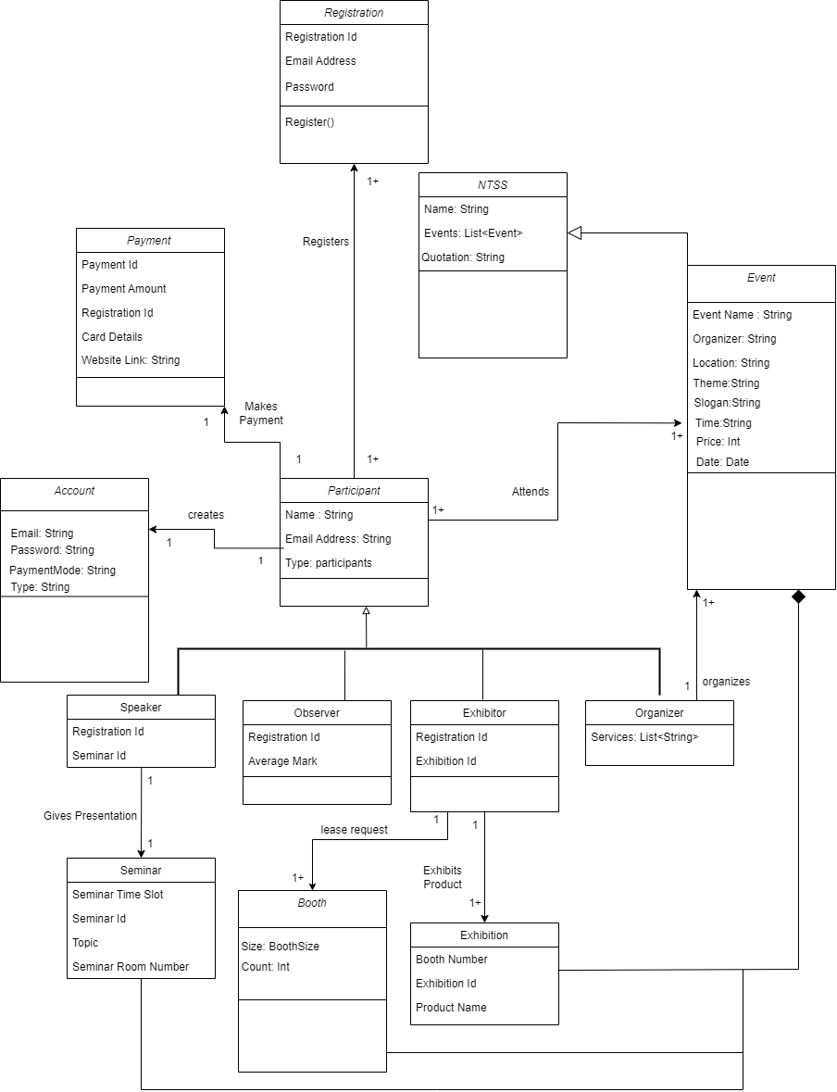

**High Level Use Case**  
**R1 NTSS allowing user to Create an Online Account  
Use case:** Create an Online Account (**Verb:** Create + **Noun**: Online Account)

**Actor:** User(Business Customer/Participant/Speaker/Exhibitor)

**System:** NTSS Application

**TUCBW:** User clicks on the create an online account button.

**TUCEW:** User sees account creation status message.

**R 1.1 NTSS allowing user to Login Using a Valid Email Address**

**Use case:** Login using valid email and password (**Ver**b :Login +**Noun**: Valid email address and password)

**Actor:** User(Business Customer/Participant/Speaker/Exhibitor)

**System:** NTSS Application

**TUCBW:** User clicks on the login button.

**TUCEW:** User is directed to NTSS Homepage.

**R 1.1.1 NTSS allowing user to change temporary password at first login**

**Use case:** change temporary password at first login(**Verb** : Change +**Noun:** temporary password)

**Actor:** User(Business Customer/Participant/Speaker/Exhibitor)

**System:** NTSS Application

**TUCBW:** User clicks on the login button.

**TUCEW:** User is prompted to change the password on first time login.

**R 1.1.2 NTSS allowing a user to request for a Password Reset**

Use case: request for password reset (**Verb:** Request **+Noun :**Password Reset**)**

Actor: User(Business Customer/Participant/Speaker/Exhibitor)

**System:** NTSS Application

**TUCBW:** User clicks on password reset button.

**TUCEW:** User is informed that the password is reset successfully.

**R2 NTSS submitting an Event Proposal form with the required fields to describe the event**

**Use case**: Submit an Event Proposal (**Verb :** Submit **+ Noun :** Event Proposal**)**

**Actor:** Event Organizer

**System:** NTSS Application

**TUCBW:** Event Organizer submits an event proposal.

**TUCEW:** Event Organizer is redirected to payment gateway.

**R2.1 Submission of the Payment Slip to the Event Organizer**

**Use case:** Provide payment(**Verb :** Submission + **Noun :** Payment Slip)

**Actor:** Event Organizer

**System:** NTSS Application

**TUCBW:** Event Organizer provides payment via payment gateway.

**TUCEW:** Event Organizer is informed about the payment and event proposal status details.

**R2.2 NTSS to change status of event proposal from “Pending Review” to “Submitted”**

**Use case:** Change an Event Proposal (**Verb :** Change + **Noun :**Event Proposal status)

**Actor:** Event Organizer

**System:** NTSS Application

**TUCBW:** Event Organizer chooses to edit the submitted event proposal.

**TUCEW:** Event Organizer is displayed about that the event proposal is modified successfully.

**R3: NTSS allows an Event Organizer to cancel an event with 15% cancellation charge)**

**Use case:** Cancel a Submitted Event Proposal (**Verb:** Cancel + **Noun**: Event)

**Actor:** Event Organizer

**System:** NTSS Application

**TUCBW:** Event Organizer selects to cancel submitted event proposal.

**TUCEW:** Event Organizer is charged 15% of the deposit fee and event proposal is canceled.

**R4 NTSS allows an Event Organizer to edit an submitted or pending review proposal**

**without any charge**

**Use case: Edit an Event Proposal (Verb :** Edit**+ Noun :**Event Proposal**)**

**Actor:** Event Organizer

**System**: NTSS Application

**TUCBW:** Event Organizer chooses to edit the submitted event proposal.

TUCEW: Event Organizer is displayed about that the event proposal is modified successfully.

**R5 NTSS Allows staff to Evaluate the Project Proposal**

**Use case:** NTSS staff to take a Decision (Acceptance /Rejection) of the Project Proposal submitted by the Event Organizer and give the feedback to the Event Organizer, If the project proposal is rejected ,a proper justification need to be given by the NTSS Staff for the Evaluation

(**Verb:** Evaluate + **Noun:** Project Proposal)

**Actor:** NTSS Staff

**System:** NTSS Application

**TUCBW:** NTSS Staff evaluates the Project Proposal and gives Decision

**TUCEW:** Event Organizers can check the decision (Acceptance/Rejection) and view the feedback and can check the justification of the rejection of the project proposal submitted.

**R6.1 :NTSS allows Exhibitor for the Submission of Booth Lease Request and Exhibitor can choose the desired size of the booth**

**Use case:** NTSS displays to choose the floor plan of the booth according to the width and the length of the booth , which has small , medium and large booths , so that according to the exhibitor’s choice they can select the size of the booth to exhibit their products.

(**Verb:** Lease request + **Noun:** Booth)

**Actor:** Exhibitor

**System:** NTSS Application

**TUCBW:** NTSS Opens display for the Exhibitors to choose the floor plan of the Booth to lease.

**TUCEW:** Exhibitors can choose the desired size of the booth according to their requirement.

**R6.2 NTSS will generate a summary and the estimation of the payment reciept and details of the allocated number of the Booth to the Exhibitor and Exhibitor can take print out of the receipt.**

**Use case:** (**Verb:** Generate, Print + **Noun:** Summary , Payment Receipt)

**Actor:** Exhibitor

**System:** NTSS Application

**TUCBW:** NTSS would be generating the summary and estimation of the payment receipt.

**TUCEW:** Exhibitors can view the allocated number and take the print out of the receipt.

**R6.3 After receiving the payment NTSS will change the status to pending review , and notification is sent to the exhibitor for his reference.**

**Use case:** (**Verb:** Change + **Noun:** Status of booth lease)

**System:** NTSS Application

**TUCBW:** NTSS will change the status to pending review and notifies the exhibitor

**TUCEW:** Exhibitors can view the status which is sent for the review and contact the NTSS for any issues or incorrect data.

**R7: NTSS allows an Exhibitor to cancel an booth lease with 10% cancellation charge)**

**Use case:** Cancel a Submitted Booth Lease Request (**Verb:** Cancel+ **Noun**: Booth lease)

**Actor:** Exhibitor

**System:** NTSS Application.

**TUCBW:** Exhibitor can cancel submitted Booth Lease Request.

**TUCEW:** Exhibitor is charged 10% of the deposit fee and Booth Lease is canceled.

**R8 NTSS Allows staff to Evaluate the Booth Lease Request**

**Use case:** NTSS staff to take a Decision (Acceptance /Rejection) of the Booth Lease Request submitted by the Exhibitor and give the feedback to the Exhbitor for the rejection. NTSS staff will give you an update of the Booth Lease Request through notification. As soon as the Booth Lease is occupied and confirmed , it is marked as Unavailable in the NTSS Portal

(**Verb:** Evaluate + **Noun:**Booth Lease Request)

**Actor:** NTSS Staff

**System:** NTSS Application

**TUCBW:** NTSS Staff evaluates the Booth Lease Request and gives Decision with the justification for the rejection. NTSS staff is also responsible to notify the status of the Booth Lease request to the Exhibitor and mark the Booth Lease slot availability to be occupied.

**TUCEW:** Exhibitors can check the decision (Acceptance/Rejection) and can check the justification of the rejection of the Booth Lease Request submitted. Exhibitors can view the notified updates by the NTSS Staff regarding the status of the Booth Lease Allocation.

**R9. NTSS allows a potential participant to register through a variety search criteria**

**Use case:** NTSS would be allowing a potential participant to do a special search .

(**Verb:** Register through variety search criteria + **Noun:**potential participant)

**Actor:** Potential Participant

**System:** NTSS Application

**TUCBW:** NTSS has a special option for the potential participant using variety search criteria.

**TUCEW:** Potential Participant can search the Event through special search criteria given by NTSS

**R10 NTSS shall allow a Potential Participant to register for one or more events.**

**Use case:**

NTSS shall allow a potential participant to register for one or more events.

(**Verb**: Register for one or more + **Noun**: Events)

**Actor**: Potential Participant

**System**: NTSS Application

**TUCBW**: Participant clicks on the Events view page to check the list of Events available.

**TUCEW**: Participant is displayed a list of events that can be selected according to interest.

**R10.1 NTSS generates the payment receipt and total payment where the Potential participant can take a print out and after receiving the payment NTSS will notify the user that the payment is received.**

**Use case:** NTSS generates the payment receipt and total payment where the Potential participant can take a print out and even after receiving the payment NTSS will notify the user that the payment is received.  
**(Verb:**Notify and Generate+**Noun:** Payment details and receipt)

**Actor**: Participant

**System**: NTSS Application

**TUCBW**: NTSS generates the payment receipt and gives the status on the participation for the event

**TUCEW**: Participant get notified about the status of the payment and confirmation of the participation and can take the print out of the payment receipt

**R11. A registered participant may cancel their registration without charge up to one week before the event, and with a 10% cancellation fee after that.**

**Use case:** A registered participant has a cool off period of one week to cancel their participation and after one week there is a cancellation fee of 10% of the total payment.

(**Verb**: Cancel + **Noun**:Registration)

**Actor**: Registered Participant

**System**: NTSS Application

**TUCBW:** Registered Participant can cancel Registration Request for free till one week before the event

**TUCEW:** Registered Participant will be charged 10 % of the cancellation fee after one week before the event.

**R12 . Allow Payment Method by NTSS through Payment Interface**

**Use case:** NTSS accepts the following payment methods: credit cards, cashier's checks, personal checks, money orders, and PayPal.

(**Verb :** Accepts + **Noun:** Payment Method)

**Actor:** Participant

**System**: NTSS Application

**TUCBW:** Participant provides payment via payment gateway like credit cards, cashier's checks, personal checks, money orders, and PayPal.

**TUCEW:** Participant is notified about the payment status and event registration details.

**Identify Use Cases Table:**

| **Req** | **Verb/Noun** | **Business Process** | **Begin w/Actor** | **End w/Actor** | **Accomplish Business Task** | **Use Case** | **Actors** |
| --- | --- | --- | --- | --- | --- | --- | --- |
| R1 | Create an online account | Y | Y | Y | Y | Y | User |
| R1.1 | Login using Email Address | Y | Y | Y | Y | Y | User |
| R1.2 | Send Temporary Password | N | N | N | Y | N | System |
| R1.3 | Change/Reset Temporary Password | N | Y | Y | Y | N | User |
| R2 | Submit Event Proposal | Y | Y | Y | Y | Y | User |
| R2.1 | Generate Payment Slip | N | N | Y | Y | N | Organizer,Exhibitor, Speaker, Observer |
| R2.2 | Change of Status | Y | N | N | Y | N | System |
| R3 | Cancel an Event | Y | Y | Y | Y | Y | Event Organizer |
| R4 | Edit an Event Proposal | Y | Y | Y | Y | Y | Event Organizer |
| R5 | Evaluate Event Proposal | Y | Y | Y | Y | Y | NTSS Staff |
| R6.1 | Submit Booth lease | Y | Y | Y | Y | Y | Exhibitor |
| R6.2 | Generate Summary and Payment Slip | N | N | Y | Y | N | System |
| R6.3 | Change status of Booth Lease | Y | N | N | Y | N | System |
| R7 | Cancel Booth Lease | Y | Y | Y | Y | Y | Exhibitors |
| R8 | View Booth Lease Request | N | Y | Y | N | N | Exhibitor/NTSS |
| R9 | Evaluate Booth Lease Request | Y | Y | Y | Y | Y | NTSS Staff |
| R10 | Register for one or more events | Y | Y | Y | Y | Y | Participant |
| R10.1 | Generate Payment Receipt and print payment Slip | N | N | Y | N | N | System |
| R11 | Cancel Registration | Y | Y | Y | Y | Y | Participant |
| R12 | Allow Payment | Y | Y | Y | Y | Y | Participant |

**USE CASE DIAGRAMS:  
  
1. Create an Account  
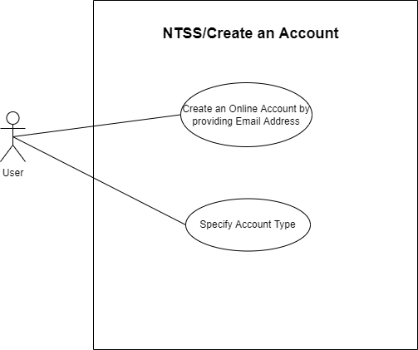**

**2. Login**

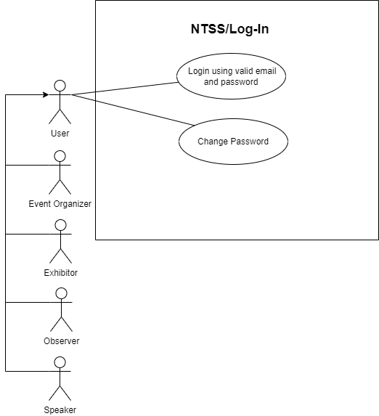

**3. Submit an Event Proposal**

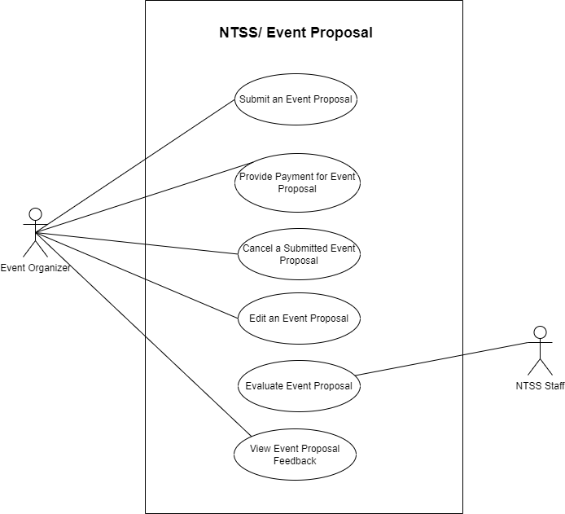

**4. Register for an Event**

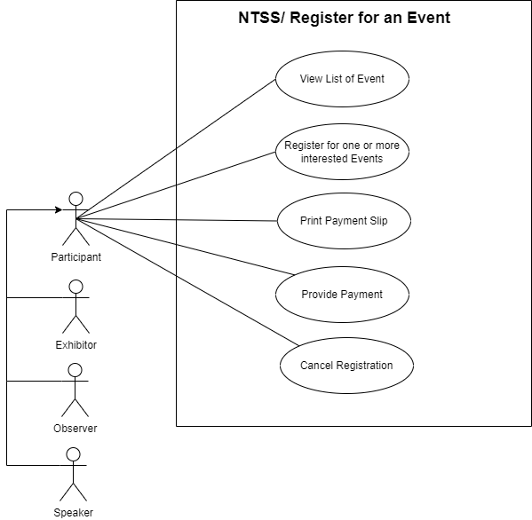

**Expanded Use Cases**

**Use Case 1: Create an Online Account**

**\*- Non-Trivial Step**

| **Actor: User** | **System: NTSS Website** |
| --- | --- |
|  | 0. The NTSS Website displays the homepage that provides a link to create an account |
| 1. **TUCBW**: The User clicks on the create an account link provided on the homepage of the NTSS Website | 2. The NTSS Website displays a form on the screen for the user to input their details |
| 3.The user provides their email address along with their account type and clicks on the Create Account Button | *4.*When the account is created, the NTSS Website shall send a temporary password to the user’s provided email address.* |
| 5. **TUCEW**: The user views the success message stating that a temporary password has been sent to their respective email. |  |

**Use Case 2: Log-In**

**\*- Non-Trivial Step**

| **Actor:User** | **System: NTSS Website** |
| --- | --- |
|  | 0. The NTSS Website displays the homepage that provides a link to Login. |
| **1. TUCBW:** The User clicks on the Login link provided on the homepage of the NTSS Website. | 2. The NTSS Website displays the options for the user to enter their email address and password on the login page. |
| 3. The User enters their email address and password on the login page. | *\*4a: If the user logs in for the first time, the NTSS Website will prompt the user to Reset their Password  *4b: If the user has logged in previously, then the NTSS Website will display a welcome page to the User signaling a successful login*. |
| 5. **TUCEW:** The user is able to see the welcome page. |  |

**Use Case 3: Submit Proposal**

**\*- Non-Trivial Step**

| **Actor: Event Organizer** | **System: NTSS Website** |
| --- | --- |
|  | 0. The NTSS Website displays the logged in user the option to redirect to the submit proposal page. |
| **1. TUCBW:** The Event Organizer clicks on the Project proposal page on the NTSS Website. | 2. The NTSS Website displays the form to submit a proposal with the fields that describe the event. |
| 3. The Event Organizer enters the details for the proposal along with the payment in the payment page and submits the form. | *\*4: NTSS Website would record all the submitted responses and send the confirmation receipt to the user. NTSS checks if the payment is received or not and changes the status to Payment Received and sends it to the user.* |
| 5. **TUCEW**: The Event Organizer is able to see their submitted responses and can check the proposal status. |  |

**Use Case 4: Register for an Event**

**\*- Non-Trivial Step**

| **Actor:User** | **System: NTSS Website** |
| --- | --- |
|  | 0. The NTSS Website shows the results for the search criteria |
| **1. TUCBW:** Users will be able to choose one or more interested events from the list of the events and register. | 2. The NTSS Website displays an event registration form to register for an event. |
| 3. The User enters all the details of the form  and submits the payment for the event and submits the form. | *\*4: The NTSS Website records the responses of the user and checks if the payment is received or not and sends a confirmation email after the payment is received.* |
| 5.**TUCEW:**The user can check the status of the event registration and payment details. |  |

**Object Interaction Modeling**

**Scenarios:**

1. **Create an Online Account**
   1. The User provides their email address and the account type and clicks on the submit button on the CreateAccount GUI.
   2. The CreateAccount GUI sends the User data to the CreateAccount Controller.
   3. The CreateAccount controller maps the User data to an User Object.
   4. The CreateAccount controller sends a request to DBManager to check if User exists in DB, if not creates the new User Object into the DB using a DBManager.
   5. The CreateAccount controller generates a successful registration message based on the successful response from DBManager.
   6. The CreateAccount controller sends the successful registration message to the CreateAccount GUI.
   7. The CreateAccount controller generates a temporary password and sends it to the user via email.
   8. The CreateAccount GUI displays the successful registration message to the user.
2. **Login**
   1. The user provides their email address and password and clicks on the Login button on the UserLogin GUI.
   2. The UserLogin GUI sends the user data to the UserLogin Controller.
   3. The UserLogin Controller maps the user data to the User Object.
   4. The UserLogin Controller sends the User Object to the DBMgr to verify whether existing LoginInfo is present in the DB.
   5. The DbMgr verifies the User Object data and sends a response to the UserLogin Controller.
   6. If existing LoginInfo is not available, then the UserLogin Controller redirects to the ChangePassword GUI. If existing LoginInfo is available, then the UserLogin Controller will generate a successful Login message.
   7. The UserLogin Controller sends the successful Login message to the UserLogin GUI.qwe92
   8. The UserLogin GUI displays the successful Login message to the user.
3. **Submit an Event Proposal**
   1. The Event Organizer provides the Event Proposal information and clicks on the submit button on the submitEvent GUI.
   2. The submitEvent GUI sends the Event Proposal data to the submitEvent Controller.
   3. The submitEvent Controller maps the event data to a new Event Object.
   4. The submitEvent Controller saves the new Event Object to the DB using a DB Manager.
   5. The submitEvent Controller directs to the paymentInfo GUI.
   6. The EventOrganizer is able to select the payment type and submit the payment on the paymentInfo GUI.
   7. The paymentInfo GUI sends the payment data to the paymentInfo Controller.
   8. The paymentInfo Controller maps the payment data to a new Payment Object.
   9. The paymentInfo Controller saves the payment Object to the DB using a DB Manager.
   10. The paymentInfo Controller generates a successful payment message based on the successful response from DBManager.
   11. The paymentInfo controller sends the successful payment message to the submitEvent GUI.
   12. The submitEvent GUI displays the successful proposal submission message to the Event Organizer.
4. **Register for an Event**
   1. The participant provides the information required for the event registration and clicks on submit button on the EventRegistration GUI.
   2. The EventRegistration GUI sends the registration data to the EventRegistration Controller.
   3. The EventRegistration Controller maps the registration data to the specific User Object.
   4. The EventRegistration Controller saves the updated User Object to the DB using a DB Manager.
   5. The EventRegistration Controller directs to the paymentInfo GUI.
   6. The Participant is able to select the payment type and submit the payment on the paymentInfo GUI.
   7. The paymentInfo GUI sends the payment data to the paymentInfo Controller.
   8. The paymentInfo Controller maps the payment data to a new Payment Object.
   9. The paymentInfo Controller saves the payment Object to the DB using a DBManager.
   10. The paymentInfo Controller generates a successful payment message based on the successful response from DBManager.
   11. The paymentInfo controller sends the successful payment message to the EventRegistration GUI.
   12. The EventRegistration GUI displays the successful event registration message to the participant.

**Scenario Table**

**Use Case 1: Create an Account**

| **#** | **Subject** | **Subject Action** | **Object** | **Object Acted on** |
| --- | --- | --- | --- | --- |
| **3.** | **User** | **provides** | **Email address/Account Type** | **CreateAccount GUI** |
| **3.** | **CreateAccount GUI** | **sends** | **User data** | **CreateAccount Controller** |
| **3.** | **CreateAccount Controller** | **maps** | **User data** | **User Object** |
| **3.** | **CreateAccount Controller** | **creates** | **User Object** | **DBManager** |
| **4.** | **CreateAccount**  **Controller** | **generates** |  | **Successful registration message** |
| **4.** | **CreateAccount Controller** | **sends** | **Successful registration message** | **CreateAccount GUI** |
| **4.** | **CreateAccount Controller** | **generates** | **Temporary Password** | **Via Email** |
| **5.** | **CreateAccount GUI** | **displays** | **Successful registration message** | **User** |

**Use Case 2: Login**

| **#** | **Subject** | **Subject Action** | **Object** | **Object Acted on** |
| --- | --- | --- | --- | --- |
| **3.** | **User** | **provides** | **Email address/Password** | **UserLogin GUI** |
| **3.** | **UserLogin GUI** | **sends** | **User data** | **UserLogin Controller** |
| **4.** | **UserLogin Controller** | **maps** | **User data** | **User Object** |
| **4.** | **UserLogin Controller** | **sends** | **User Object** | **DBManager** |
| **4.** | **DbManager** | **verifies** | **User Object** | **UserLogin Controller** |
| **4.** | **UserLogin Controller** | **redirects** | **LoginInfo** | **ChangePassword GUI** |
| **4.** | **UserLogin Controller** | **generates** |  | **Successful Login message** |
| **4.** | **UserLogin Controller** | **sends** | **Successful Login message** | **UserLogin GUI** |
| **5.** | **UserLogin GUI** | **displays** | **Successful Login message** | **User** |

**Use Case 3: Submit an Event Proposal**

| **#** | **Subject** | **Subject Action** | **Object** | **Object Acted on** |
| --- | --- | --- | --- | --- |
| **3.** | **Event Organizer** | **provides** | **Event Proposal Information** | **submitEvent GUI** |
| **3.** | **submitEvent GUI** | **sends** | **Event Proposal data** | **submitEvent Controller** |
| **4.** | **submitEvent Controller** | **maps** | **Event data** | **Event Object** |
| **4.** | **submitEvent Controller** | **saves** | **Event Object** | **DBManager** |
| **4.** | **submitEvent Controller** | **directs** |  | **paymentInfo GUI** |
| **4.** | **Event Organizer** | **selects/submit** | **Payment type/Payment** | **paymentInfo GUI** |
| **4.** | **paymentInfo GUI** | **sends** | **Payment Data** | **paymentInfo Controller** |
| **4.** | **paymentInfo Controller** | **maps** | **Payment Data** | **Payment Object** |
| **4.** | **paymentInfo Controller** | **saves** | **Payment Object** | **DBManager** |
| **4.** | **paymentInfo Controller** | **generates** |  | **Successful Login message** |
| **4.** | **paymentInfo Controller** | **sends** | **Successful Payment message** | **submitEvent GUI** |
| **5.** | **submitEvent GUI** | **displays** | **Successful Payment message** | **Event Organizer** |

**Use Case 4: Register for an Event**

| **#** | **Subject** | **Subject Action** | **Object** | **Object Acted on** |
| --- | --- | --- | --- | --- |
| **3.** | **Participant** | **provides** | **Event Registration Information** | **EventRegistration GUI** |
| **3.** | **EventRegistration GUI** | **sends** | **Registration data** | **EventRegistration Controller** |
| **4.** | **EventRegistration Controller** | **maps** | **Registration data** | **User Object** |
| **4.** | **EventRegistration Controller** | **saves** | **User Object** | **DBManager** |
| **4.** | **EventRegistration Controller** | **directs** |  | **paymentInfo GUI** |
| **3.** | **Participant** | **selects/submit** | **Payment type/Payment** | **paymentInfo GUI** |
| **4.** | **paymentInfo GUI** | **sends** | **Payment Data** | **paymentInfo Controller** |
| **4.** | **paymentInfo Controller** | **maps** | **Payment Data** | **Payment Object** |
| **4.** | **paymentInfo Controller** | **saves** | **Payment Object** | **DBManager** |
| **4.** | **paymentInfo Controller** | **generates** |  | **Successful Login message** |
| **4.** | **paymentInfo Controller** | **sends** | **Successful Payment message** | **eventRegistration GUI** |
| **5.** | **eventRegistration GUI** | **displays** | **Successful Payment message** | **Participant** |

**Informal Sequence Diagrams:  
  
1. Create Account:  
  
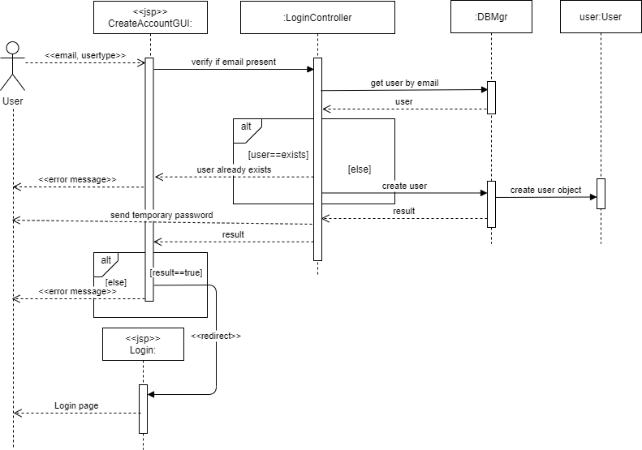**

**2. User Login:**

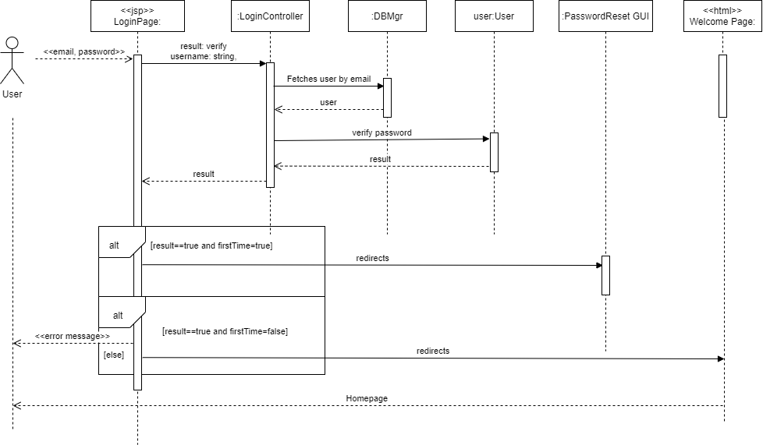

**3. Submit an Event Proposal:  
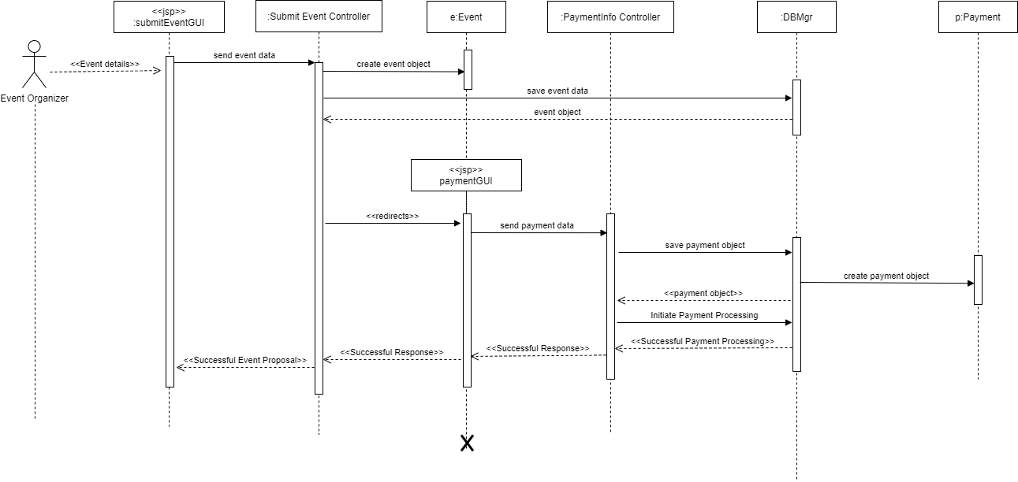**

**4. Register for an Event:  
  
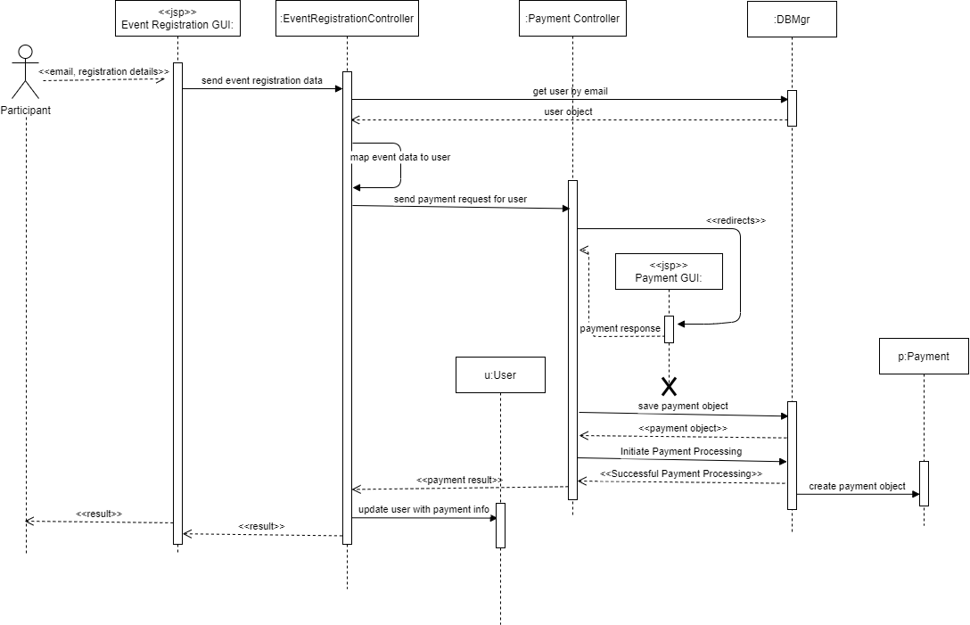**

**Design Sequence Diagrams:**

**1. Create Account:**

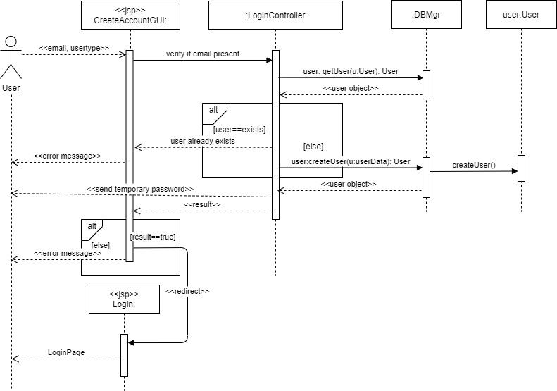

**2. Login:  
  
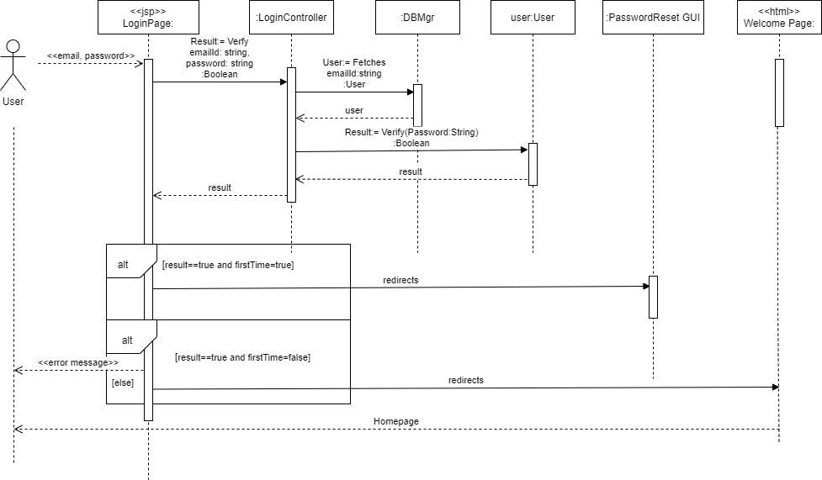**

**3. Submit an Event Proposal:**

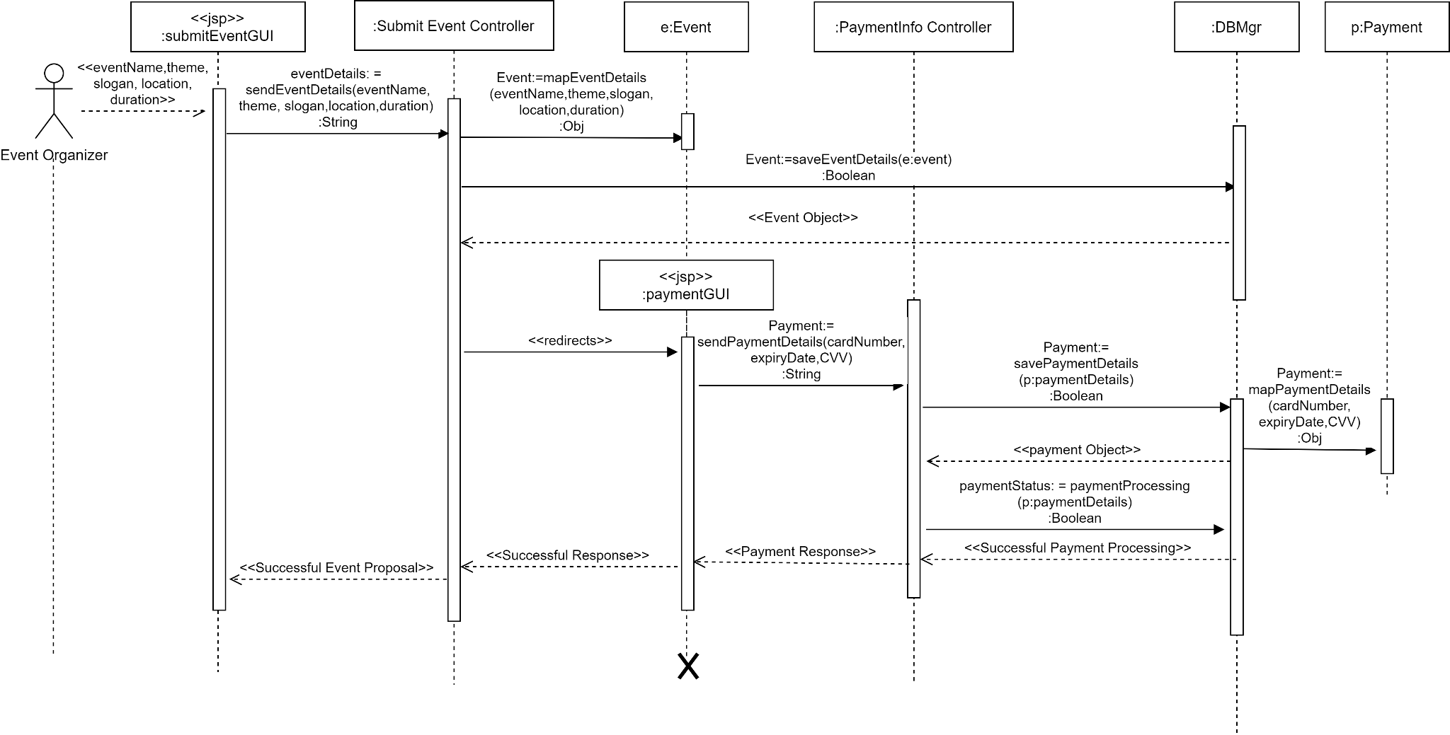

**4. Register for an Event:**

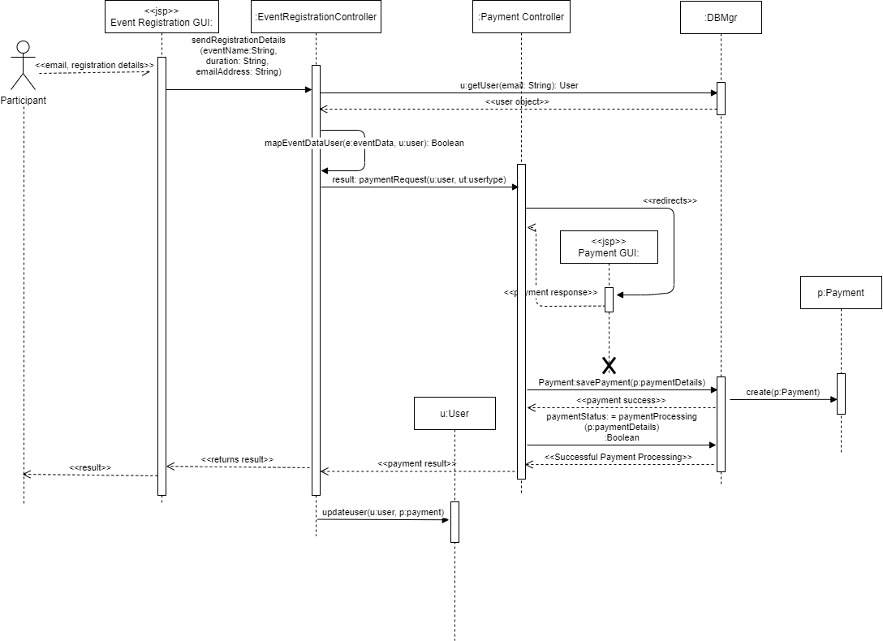

**Design Class Diagram**

